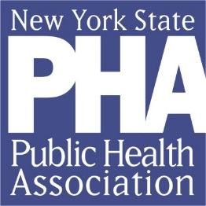
NYSPHA Policy and Advocacy Committee

2017 Activities and Accomplishments
- Sent a proactive Letter to the Governor about increasing funding for public health in the Exec. Budget
- Supported Rockland Tobacco Free Pharmacy bill - Passed
- Supported APHA letter to congress to fight weakening FDA regulation of tobacco – e cigs, and small cigars and Signed on to a letter to Senator Schumer and Rep Lowry to help prevent funding cuts for the CDC’s Office of Smoking and Health and exempt cigars and/or e-cigarettes from FDA regulation
- Signed letter to Congressional delegation to fight weakening of school lunch regulations and cuts to nutrition programs.
- Signed on to APHA memo in support of ACA
- Sent out several action alerts to thousands of members and contacts requesting calls to legislators, leaders, and the Governor to stop the 20% cut to public health programs.
- Sign on to the NYS Aid in Dying bill
- Used Twitter for the first time to support NYS policies and increased followers
- Signed on to an organizational letter to oppose the delay and weakening of the menu labeling regulation
- Day at the Capitol – Fifteen members participated. Collaborated with Heart and Lung Associations to push for Tobacco 21
- Released an E-cig Policy Paper with recommendations to pass T21 and E-cig Loophole law.
- Helped pass the legislation to close the E-cig loophole in the CIA
- Helped get Tobacco 21 through the Health Committees in both houses
- Helped the tobacco free SUNY bill pass the Assembly

