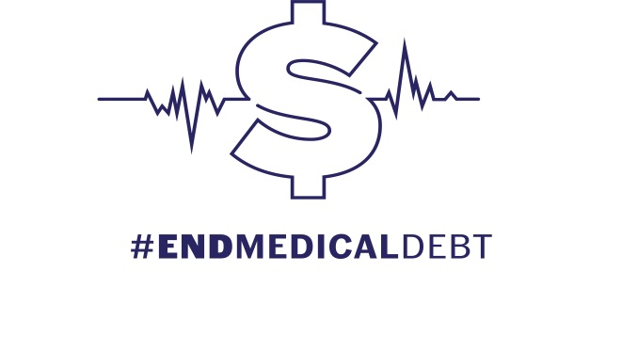
May 9, 2022

CONTACT: Jeff Maclin, Community Service Society
718-309-2346 / jmaclin@cssny.org

Daniel Hopkins, Long Island Progressive
989-387-1226 / dhopkins@lipc.org

Blair Horner, NYPIRG
518 727-4506 / bhorner@nypirg.org

Dana Balter, Citizen Action New York

518-618-2790 / dbalter@citizenactionny.com

Erik Kriss, AARP New York
518-360-9213 / ekriss@aarp.org

Hospitals Must Stop Putting Liens on Patients’ Homes and Garnishing Their Wages
The End Medical Debt Coalition and Legislative Sponsors Hold Press Conference Urging
the New York State Senate to Pass S.6522A to Protect Patients

The End Medical Debt Coalition today held a press conference with State Senate Health Committee Chair and bill sponsor Gustavo Rivera and Assembly Health Committee Chair and bill sponsor Richard Gottfried calling upon the Senate to pass Senate bill S.6522A, which protects patients from liens against their primary residence and wage garnishment due to money judgments arising from debt collection actions by hospitals or health care professionals.
Standing in the Capitol Rotunda, State Senator Rivera urged his colleagues to tell leadership that it is time to call for a vote: “New Yorkers should not fear losing their homes as a result of seeking the medical care they need. It is unconscionable that some hospitals and health care providers in New York State continue to mercilessly file liens on their patients' homes in order to collect their medical debt. I urge my colleagues in the Senate to join me in passing my bill to eradicate this nefarious practice in our State and take a significant step to end medical debt once for all.”
The accompanying Assembly bill A.7363A passed that chamber on March 23rd led by Assembly Health Committee Chair and prime sponsor Richard Gottfried.
"People's lives have been destroyed by the unconscionable and shocking practices by some health care facilities of putting liens on patients' homes and garnishing wages for an average claim of $1,900. I commend the Community Service Society for its research and advocacy and am hopeful the Senate will pass this bill protecting patients from these abuses,” said Assemblymember Gottfried.
Praising the Assembly for passing its version, advocates representing some of the 50 organizations included in the End Medical Debt Coalition called on the Senate to follow suit and send the bill to Governor Kathy Hochul for her signature.
Bethsy Morales-Reid, Assistant Vice President of Programs with the Hispanic Federation, said: “Communities of color experience the most disproportionate rate of medical debt because of predatory financial practices in New York State. No one should fear seeking medical treatment for jeopardy of losing their home or wages. Yet, this is a reality for low-income consumers every day in our state. The Senate must pass this bill and put an end to these harmful practices."
“NYPIRG commends the Assembly for taking action and we stand today with Senator Rivera calling on the Senate to pass this bill and put an end to these unnecessary and harsh financial practices,” said Blair Horner, Executive Director of the New York Public Interest Research Group (NYPIRG).
“New Yorkers shouldn’t have to fear losing their homes or their wages because they need medical care,” said Beth Finkel, New York State Director for AARP. “These bills would help prevent that kind of onerous medical debt collection, which disproportionately impacts the poor and New Yorkers of color - who are already nearly twice as likely as white New Yorkers to face medical debt. Ten other states have already banned pursuit of debtors’ homes, and four states have prohibited pursuit of debtors’ wages. New York should join them.”
New York residents overwhelmingly support this legislation. According to a Robert Wood Johnson Foundation-funded Poll by Perry/Undem, released in March 2022, more than 70 percent of New Yorkers favor the enactment of S.6522A/A.7363A.
“This bill is wildly popular on Long Island with almost three out of four people supporting its passage,” said Daniel Hopkins, Communications Coordinator for the Long Island Progressive Coalition. “The Senate must act now. Saving people’s homes from the effects of healthcare costs should be a priority, especially after two years of living through a pandemic.”
"We are here today to ask our state senators for help and demand they pass this bill,” said Mel Gagarin, Deputy Legislative Director for Citizen Action of New York. “Hospitals in New York State are non-profit organizations and yet they act like the worst corporate actors by putting profits over patients. These aggressive debt collection practices disproportionately impact communities of color and low wage workers. These egregious practices must end now.”
In many communities such as Albany, Erie, Monroe, and Westchester, people of color are more than twice as likely to be carrying medical debt than are white residents. A 2021 Community Service Society report found that 56 hospitals in New York filed more than 4,800 liens against patients’ homes in 2017 and 2018. The median outstanding medical debt that triggered these lawsuits is only $1,900. The overwhelming majority of hospitals do not sue their patients over medical debt. Of the 220 hospitals in New York State, 20 account for 75 percent of all the medical debt lawsuits.
“Medical debt is one of the most crippling aspects of our health care system,” said Becca Telzak, Deputy Director of Make the Road New York. “In New York State alone, there are stark disparities in the share of medical debt reported to collections among communities of color. The End Medical Debt bill package will ban liens and wage garnishments, protect patients from unreasonable facility fees, will work to make the medical system easier to navigate, and more. We must work to ensure that this package passes this legislative session and help the most vulnerable New Yorkers, which are often our immigrant, Black and Brown communities. It is time New York moves away from predatory hospital systems and allows New Yorkers the peace of mind to seek medical care without the fear of financial ruin.”
Elisabeth Benjamin, Vice President of Health Initiatives at the Community Service Society, said: “I want to thank Senator Rivera for having the courage to take on this issue and make it a priority for this legislative session. I have been proud to work with this truly diverse coalition of 50 organizations to bring this issue to the attention of New York’s legislature. The Assembly heard our call and with the help of Assembly sponsor Dick Gottfried, passed the bill in March. We are here today hoping the Senate also hears our call and acts to pass the bill. Now.”
The End Medical Debt Coalition consists of 50 organizations:
- AARP
- ACR Health
- African Services Committee
- Asian Americans for Equality
- Bend the Arc: Jewish Action Long Island
- Center for Independence of the Disabled - NY
- Churches United for Fair Housing
- Citizen Action
- Coalition for Asian American Children and Families
- Commission on the Public's Health System
- Community Service Society of New York
- Consumer Reports
- DeQH
- District Council 37
- Dutchess County Progressive Action Alliance
- Empire Justice Center
- Health and Welfare Council of Long Island
- Health Care for All New York/CSS
- Hudson Valley Demands New York Health
- Labor-Religion Coalition of NYS
- League of Women Voters of St. Lawrence County
- Long Island Activists
- Long Island Center for Independent Living, Inc. (LICIL)
- Long Island Progressive Coalition
- Make the Road NY
- Medicare Rights Center
- Metro Justice
- Metro NY Health Care for All
- Muslims For Progress
- New York Association on Independent Living
- New York Progressive Action Network
- New York Public Interest Research Group
- New York State Council of Churches
- New York State Nurses Association
- New York State Public Health Association
- New York StateWide Senior Action Council, Inc.
- Northwest Bronx Indivisible
- NYC Democratic Socialists of America
- NYCD16 Indivisible
- NYS NAACP
- PEER/NYPAN, Suffolk County
- Physicians for a National Health Program - NY Metro
- Public Issues Committee, LI Council of Churches
- Resource Center for Accessible Living
- Social Justice Committee at the UU Congregation at Shelter Rock
- South Asian Council for Social Services
- Southampton Town Democratic Committee
- Suffolk Progressives
- The Actors Fund
- Together We Will Long Island

###

