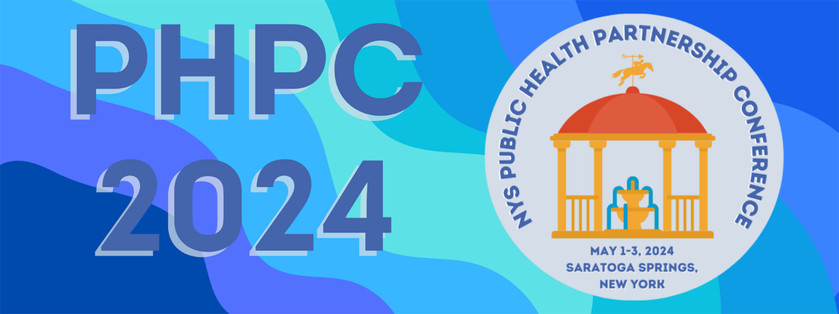

“Building Trust in Public Health to Foster Health Equity”

Call for Student Poster Abstracts

The New York State Public Health Association (NYSPHA), New York State Association of County Health Officials (NYSACHO), New York State Association for Rural Health (NYSARH) invite you to submit a proposal to present your student work at the 2024 Public Health Partnership Conference “Building Trust in Public Health to Foster Health Equity.”
The event will be held May 2-3, 2024, at the Hilton & Saratoga Springs City Center in Saratoga, New York. A pre-conference Poverty Simulation workshop followed by a Welcome Networking & Awards Reception will be held the afternoon/evening of May 1st. This one-of-a-kind event brings together public health professionals from all settings to engage in learning opportunities designed to enhance personal growth and renewal, as well as to benefit the communities we all serve. We thank you for your participation and engagement.

If:
- You are a student at a New York university or college
- You are passionate about public health
- You have an interesting paper, project, or research study to share that has not been previously presented. (Projects must be original student research and cannot have been previously presented at a conference or other public forum.)

Here is your opportunity to design a poster that has a specific focus of one of the following themes:

- Innovative Public Health Communication Strategies
  - Best practices for health communication, reaching your target community

Addressing Health Equity and Health Disparities

Accessing and providing quality healthcare services to marginalized and underserved communities
- Recruitment and Retention Strategies for Enhancing Public Health Infrastructure
  - Workforce training, new technology
- Supporting Diverse Populations in Communities
  - Acknowledging different backgrounds and cultures in public health interventions
- Improving Mental Health and Wellbeing
  - Building support systems
- Building Public Health Partnerships and Collaborations
  - Interprofessional collaboration and communication
- Protecting Against Climate Change and Environmental Health Risks
  - Public policy, education, healthy neighborhoods

Other areas of public health may be submitted; however, priority will be given to those that meet the above criteria.

Proposal Requirements
Date:
Student Name:
Student e-mail:
Student phone #:
Student University/College:
- Topic of your poster:
Relevant theme (Please check one)
☐ Innovative Public Health Communication Strategies
☐ Addressing Health Equity and Health Disparities
☐ Recruitment and Retention Strategies for Enhancing Public Health Infrastructure
☐ Supporting Diverse Populations in Communities
☐ Improving Mental Health and Wellbeing
☐ Building Public Health Partnerships and Collaborations
☐ Protecting Against Climate Change and Environmental Health Risks
- Have you displayed or presented your poster for another event/class?
- (If yes, where/why?)

- Please provide a short paragraph to summarize the topic of your poster (e.g., focus, target audience, hypothesis, findings etc.). Be sure to include how your project impacts public health.
- Why should we select your poster to showcase at the 2024 NYS Public Health Partnership Annual Conference?

Poster abstracts will be reviewed by a committee on the following criteria:
- Relevance to the conference theme and public health
- Engaging for public health professionals
- Originality
- Educational value
- Overall presentation

How to Submit

- All student poster abstract proposals must be submitted online via our abstract submission website HERE (https://app.oxfordabstracts.com/stages/6731/submitter)
- Submissions must be made by 5:00 PM on February 29, 2024. Submissions sent via email will not be considered.
- Presenters may not submit more than one proposal.

Please complete the acknowledgement information below and submit the document through submission
portal.

☐ By checking this box, I certify that this is my original work and give permission to share my work, my name, and my photo. I acknowledge that submitted materials are the property of NYSPHA and may not be returned unless requested. I further agree that my project has not been previously presented at a conference or other public forum.

Students who are selected to present their posters will receive a free conference registration for Day 2 of the conference (May 2nd). Students who wish to attend the pre-conference and/or Day 3 of the conference (May 3rd) can register at the discounted student rate. If your poster is selected for display, you must attend the conference in person to present your poster.

☐ I agree that if my poster is selected I will attend the conference in person to present my poster. I will also prepare a digital presentation to share with the virtual attendees.

Decisions will be made by April 1, 2024, and we will provide you with logistical instructions. We hope you will consider submitting a poster - we look forward to seeing you in early May.

Please contact Denise Tahara with any questions:
Denise C. Tahara, NYSPHA Immediate Past-President, Student Poster Coordinator
Email: denise@nyspha.org

