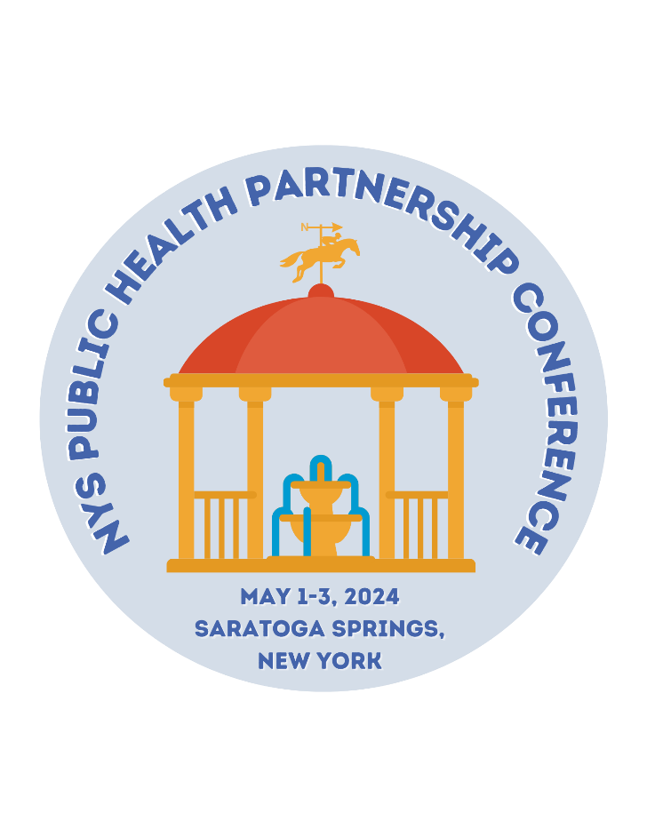
Building Trust in Public Health
to Foster Health Equity

2024

SPONSORSHIP PROSPECTUS

Public Health Partnership Conference
May 1-3, 2024

Saratoga Springs, NY

About NYSPHA
The New York State Public Health Association (NYSPHA) is an affiliate of the American Public Health Association and serves as a statewide organization for members from all disciplines in the public health spectrum including state and county health departments, healthcare; policy and advocacy organizations; community-based health and human service programs and workers; academia and research. NYSPHA advocates for policies at the national, state and regional levels that support equity in health status and an end to health disparities for all.
NYSPHA’s mission is to promote and protect the public’s health through professional development, networking, advocacy and education. To learn more visit www.nyspha.org .

About NYSACHO
The New York State Association of County Health Officials (NYSACHO) supports, advocates for, and empowers local health departments in their work to promote health and wellness and prevent disease, disability and injury throughout New York State. To learn more visit: www.nysacho.org

About NYSARH
The New York State Association for Rural Health is a not-for-profit, non-partisan, grassroots membership organization working to preserve and improve health and human services in rural New York State. NYSARH is a member of the National Rural Health Association. To learn more visit: www.nysarh.org

About Saratoga Hilton & City Center

Located in Saratoga Springs, New York, 2 mi from the Saratoga Race Course, this nonsmoking hotel offers on-site dining along with a number of modern facilities and 24-hour front desk service. On-site at the Saratoga Hilton, guests can enjoy wireless internet access, state-of-the-art fitness facilities and an indoor swimming pool. Offering American inspired cuisine, the on-site restaurant The Springs serve breakfast, lunch and dinner. Saratoga Spa State Park and Saratoga Performing Arts Center are 2.8 mi away from The Saratoga Hilton. The adjacent Saratoga Springs City Center offers 32,000 square feet of easily adaptable meeting and convention space. To learn more visit: https://www.hilton.com/en/hotels/albsahf-the-saratoga-hilton/

About the Public Health Partnership Conference
We invite you to join us for a leading-edge public health conference being held in person this year in Saratoga Springs, NY. This is our largest event of the year attracting hundreds of attendees from all parts of New York State and beyond.

This collaborative conference will offer scientific sessions in a variety of formats including large plenary sessions and smaller concurrent sessions.

The conference is tailored to public health educators, academic staff, county health officials and employees, students, medical and dental practitioners, state health employees and others in the field of public health, education and medical care.

We welcome all individuals, public servants, and organizations who share a common interest in promoting and protecting the public’s health.

Fast Facts

★ May 1-3, 2024 – Saratoga Springs
★ 250+ attendees
★ Two Keynote Addresses:
★ TBD
★ Commissioner, NYS Department of Health
★ Attendees represent a broad spectrum of public health and healthcare professionals: Program administrators, coordinators, health educators, local and state health department officials and staff, nonprofit organizations, behavioral services, healthcare organizations, academia, research, and students
★ Sessions to address best practices, innovations, access and new and emerging issues in public health and community wellness
★ Networking events for all attendees
★ For continually updated information and to register, visit
★Exhibitor set-up details
- Set Up: Wednesday, May 1st from 12:00-4:00 p.m.
- Breakdown: Thursday, May 2nd from 7:00-9:00 p.m.

Opportunities

Level |  | Investment
Parking Sponsor |  | $6,000
Platinum Sponsor- Awarded |  | $5,500
Thursday Luncheon Sponsor- Awarded |  | $5,000
Thursday Plenary Sponsor |  | $4,500
Friday Plenary Sponsor |  | $4,000
Friday Lunch-to-Go Sponsor |  | $3,500
Lounge Sponsor |  | $3,500
Thursday Poster Session Sponsor |  | $3,000
Friday Poster Session Sponsor |  | $3,000
Networking Reception Sponsor |  | $2,500
Coffee Break Sponsor [three available] |  | $2,500
Concurrent Session Sponsor [eight available] |  | $2,000
Charging Station Sponsor |  | $2,000
Pharma Exhibitor |  | $1,000
Corporate Exhibitor |  | $1,000
Not-for Profit Exhibitor |  | $600
NYSPHA/NYSARH Member Exhibitor |  | $500
Virtual Only Exhibitor |  | $200
Raffle Prize |  | product
Bag Stuffer |  | product

Parking Sponsor $6,000

Sponsorship Includes:
- Parking validation machine will be given to you to have at your booth. Attendees that utilize the parking garage will have to come to your booth to have their parking ticket validated.
- Banner Ads in the Mobile Conference App
- Logo prominently displayed on NYSPHA & NYSARH websites
- Sponsor site in Whova Exhibitor Center and Sponsor Center
- Social Media posts on Partners pages
- Conference center individual poster signage
- Acknowledgement during the event
- Opportunity to speak or show a brief video
- Four complimentary event registration tickets
- Complimentary Exhibitor Booth

Platinum Sponsor $5,500

Sponsorship Includes:
- Banner Ads in the Mobile Conference App
- Logo prominently displayed on NYSPHA & NYSARH websites
- Sponsor site in Whova Exhibitor Center and Sponsor Center
- Social Media posts on Partners pages
- Conference center individual poster signage
- Acknowledgement during the event
- Opportunity to speak or show a brief video
- Three complimentary event registration tickets
- Complimentary Exhibitor Booth

Thursday Luncheon Sponsor- AWARDED $5,000 Sponsorship Includes:
- Banner Ads in the Mobile Conference App
- Logo prominently displayed on NYSPHA & NYSARH websites
- Sponsor site in Whova Exhibitor Center and Sponsor Center
- Social Media posts on Partners pages
- Conference center individual poster signage
- Acknowledgement during the event
- Opportunity to speak or show a brief video
- Three complimentary event registration tickets
- Complimentary Exhibitor Booth

Thursday Plenary Sponsor $4,500

Sponsorship Includes:
- Banner Ads in the Mobile Conference App
- Logo prominently displayed on NYSPHA & NYSARH websites
- Sponsor site in Whova Exhibitor Center and Sponsor Center
- Social Media posts on Partners pages
- Conference center shared poster signage
- Acknowledgement during the event
- Opportunity to speak or show a brief video
- Two complimentary event registration tickets
- Complimentary Exhibitor Booth

Friday Plenary Sponsor $4,000

Sponsorship Includes:
- Banner Ads in the Mobile Conference App
- Logo prominently displayed on NYSPHA & NYSARH websites
- Sponsor site in Whova Exhibitor Center and Sponsor Center
- Social Media posts on Partners pages
- Conference center shared poster signage
- Acknowledgement during the event
- Opportunity to speak or show a brief video
- Two complimentary event registration tickets
- Complimentary Exhibitor Booth

Friday Lunch-to-Go Sponsor $3,500
Sponsorship Includes:
- Banner Ads in the Mobile Conference App
- Logo prominently displayed on NYSPHA & NYSARH websites
- Sponsor site in Whova Exhibitor Center and Sponsor Center
- Social Media posts on Partners pages
- Conference center table top signage
- Acknowledgement during the event
- One complimentary event registration tickets
- Complimentary Exhibitor Booth

Lounge Sponsor $3,500
Sponsorship Includes:
- Banner Ads in the Mobile Conference App
- Logo prominently displayed on NYSPHA & NYSARH Websites
- Sponsor site in Whova Exhibitor Center and Sponsor Center
- Social Media posts on Partners pages
- Acknowledgement during the event
- Signage at lounge
- One complimentary event registration tickets
- Complimentary Exhibitor Booth

Poster Session Sponsor $3,000
Sponsorship Includes:
- Banner Ads in the Mobile Conference App
- Logo prominently displayed on NYSPHA & NYSARH websites
- Sponsor site in Whova Exhibitor Center and Sponsor Center
- Social Media posts on Partners pages
- Conference center entrance signage
- Acknowledgement during the event
- One complimentary event registration tickets
- Complimentary Exhibitor Booth

Networking Reception Sponsor $2,500
Sponsorship Includes:
- Banner Ads in the Mobile Conference App
- Logo prominently displayed on NYSPHA & NYSARH websites
- Sponsor site in Whova Exhibitor Center and Sponsor Center
- Conference center table top signage
- Acknowledgement during the event
- One complimentary event registration tickets
- Complimentary Exhibitor Booth

Coffee Break Sponsor $2,500
Sponsorship Includes:
- Banner Ads in the Mobile Conference App
- Logo prominently displayed on NYSPHA & NYSARH websites
- Sponsor site in Whova Exhibitor Center and Sponsor Center
- Conference center table top signage
- Acknowledgement during the event
- One complimentary event registration tickets
- Complimentary Exhibitor Booth

Concurrent Session Sponsor $2,000
Sponsorship Includes:
- Banner Ads in the Mobile Conference App
- Logo prominently displayed on NYSPHA & NYSARH websites
- Sponsor site in Whova Exhibitor Center and Sponsor Center
- Conference center entrance signage
- Acknowledgement during the event
- One complimentary event registration ticket
- Complimentary Exhibitor Booth

Charging Station Set on Illuminated Table with Logo $2,000
Sponsorship Includes:
- Banner ads in the Mobile Conference App
- Logo prominently displayed on NYSPHA & NYSARH websites
- Sponsor site in Whova Exhibitor Center and Sponsor Center
- Acknowledgement during the event
- Logo at charging station
- One complimentary event registration ticket
- Complimentary Exhibitor Booth

Pharma Spotlight $ 1,000
Exhibitor Levels
Corporate Exhibitor $ 1,000

Not-for-Profit Exhibitor $ 600

NYSPHA/NYSARH Member Exhibitor $ 500

Second Person at Exhibitor Table $ 250
- If you’d like to bring an additional staff person at your exhibitor booth, you will need to purchase a separate attendee ticket. This ticket will include meals and the opening reception for your additional staff member. To purchase the separate ticket (for $250 plus service fees), please use the attendee registration page: https://whova.com/portal/registration/phpcn_202404/.
- Once you register your additional staff member, you can then assign them to your booth using the exhibitor hub.

Exhibitor Benefits Include:
- Exhibitor site in Whova Exhibitor Center
- Acknowledgement during the event
- One complimentary event registration ticket
- Complimentary Exhibitor Booth

Digital Only Exhibitor $ 200

Exhibitor Benefits Include:
- Exhibitor site in Whova Exhibitor Center
- Acknowledgement during the event

Product Contributions
The Public Health Partnership Conference welcomes donations of health and wellness oriented products for conference attendees as swag items or raffle prizes.

Note:
Pharmaceutical companies are eligible for the Pharma Spotlight only.

Availability and Deadline:

Space is limited: Sponsorships are available on a first-come, first-served basis.
The sponsorship deadline is April 17, 2024, or when all sponsorships have been awarded, whichever comes first.

The Public Health Partnership Sponsorship Committee reserves the right to reject applications from those sponsors whose products and services do not support the public health goals of the conference. Please visit www.nyspha.org/annualmeeting for a detailed statement of NYSPHA’s advertising and sponsorship guidelines, including criteria for prospective conference sponsors and supporters. Sponsorships and Exhibitors must adhere to organizational sponsorship policy guidelines.

For more information on sponsorship and exhibiting opportunities, please contact your outreach representative:

Lauren Sears
Communications Specialist
New York State Public Health Association (NYSPHA)
lauren@nyspha.org

Sara Wall Bollinger
Director for Strategic Development
New York State Association for Rural Health (NYSARH)
Sara@nysarh.org

Laura Gibson
Program and Event Planning Specialist
New York State Association for County Health Officials (NYSACHO)
Lgibson@nysacho.org

The Public Health Partnership Conference is using Whova for sponsors, exhibitors and conference participants.
This platform provides exceptional sponsor and exhibitor opportunities to engage with both in-person and virtual conference attendees.
All sponsors, exhibitors and poster presenters need to set up their sites in Whova prior to April 17,2024. Sponsors who set up their sites early will gain additional impressions as registrants join the site.
Attendees depend on your documents, recordings and chats in Whova. Please take advantage of the attendee engagement, lead generation and contest opportunities that Whova provides. https://whova.com/virtual-conference-platform/

